Assignment 2

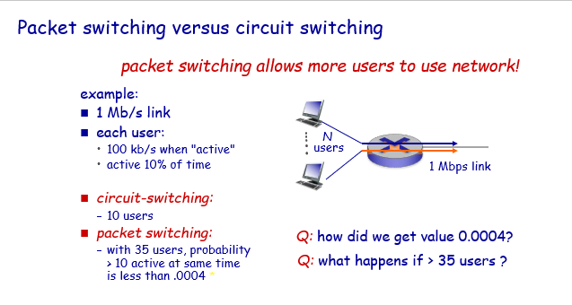

Q: how did we get value 0.0004?

Ans **By using binomial distribution**

**Prob(# active users = 10) C(35, 10)*0.1^10*0.9^25 = 0.00131791**

**Prob(# active users > 10) = 1-Prob(#active = 10)-Prob(#active = 9)-Prob(#active = 8)-…-Prob(#active = 0)**

**= 1-0.00131791 - 0.00456201 - 0.013686 - 0.0351926 - 0.0764529 - 0.137615 - 0.199764 - 0.224735 - 0.183874 - 0.0973449 - 0.0250316 = 0.00042408**

Q: What happens if > 35 users?

Ans **if > 35 users then packet switching can’t support all 35 users at once.**

P8. Suppose users share a 10 Mbps link. Also suppose each user requires 200 kbps when transmitting, but each user transmits only 10 percent of the time. (See the discussion of packet switching versus circuit switching in Section 1.3.)

a. When circuit switching is used, how many users can be supported?

Ans **10000 kbps/ 200kbps = 50 users**

b. For the remainder of this problem, suppose packet switching is used. Find the probability that a given user is transmitting.

Ans **Transmission rate = 10%**

**Probability = 1/10 = 0.1**

c. Suppose there are 120 users. Find the probability that at any given time, exactly n users are transmitting simultaneously. (Hint: Use the binomial distribution.)   
Ans **P(n users are transmitting at the same time) = C(120, n) * (1/10)^n * (9/10)^120-n**

d. Find the probability that there are 51 or more users transmitting simultaneously.

Ans **P(51 or more users) = $\sum_{n=51}^{120}{P(n users are transmitting at the same time)}$**

**Since we know that there are 120 users, and the probability that more than 51 users transmit at the same time can be calculated using the previous formula n which it should apply the following condition: 51 ≤ n < 120.**

P25. Suppose two hosts, A and B, are separated by 20,000 kilometers and are connected by a direct link of R = 5 Mbps. Suppose the propagation speed over the link is 2.5 * 10^8 meters/sec.

a. Calculate the bandwidth-delay product, R * dprop.

Ans $d_{prop }=\frac{d}{s}$

$= \frac{20000000 m}{2.5 x {10}^{8} m/s} = 0.08 sec$

**R $d_{prop }$* = 5 Mbps x 0.08 sec = 400000 bits**

b. Consider sending a file of 800,000 bits from Host A to Host B. Suppose the file is sent continuously as one large message. What is the maximum number of bits that will be in the link at any given time?

Ans **R $d_{prop }$* = 5 Mbps x 0.08 sec = 400000 bits**

c. Provide an interpretation of the bandwidth-delay product.

Ans **The bandwidth-delay product shows us the bit capacity of the link.**

d. What is the width (in meters) of a bit in the link? Is it longer than a football field?

Ans $\frac{20000000 m}{400000 bits} =$**50 m, which is not longer than football field.**

e. Derive a general expression for the width of a bit in terms of the propagation speed s, the transmission rate R, and the length of the link m.

Ans $\frac{m x s}{R}$

P27. Consider problem P25 but now with a link of R = 500 Mbps.

a. Calculate the bandwidth-delay product, R * dprop.

Ans **d = 20000 km = 20000000 m**

**R = 500 Mbps = 500000000 bps**

**S = 2.5 * 10^8 meters/sec**

$d_{prop }=\frac{d}{s}$**= $\frac{2x{10}^{7}}{2.5x{10}^{8}}$ = 0.08sec**

**R x $d_{prop }=$ 500000000 x 0.08 = 40000000 bits**

**Therefore, the bandwidth-delay product is 40000000 bits**

b. Consider sending a file of 800,000 bits from Host A to Host B. Suppose the file is sent continuously as one big message. What is the maximum number of bits that will be in the link at any given time?

Ans L = 800000 bits, **R = 500 Mbps = 500000000 bps**

**R x $d_{prop }=$ 500000000 x 0.08 = 40000000 bits**

**Maximum number of bits that will be in the link at any given time = min(bandwidth-delay product, packet size) = min(40000000 bits, 800000 bits) = 800000 bits**

c. What is the width (in meters) of a bit in the link?

Ans $\frac{20000000 m}{40000000 bits}$ **= 0.5 m**

**Chaiwat Plongkaew 2021326660023**